EXP.NO: 1
Web Page Creation using HTML

AIM:
To create a web page that embeds a map with hotspots, frames, and links. The web page should be designed using HTML, incorporating embedded, external, and inline CSS for styling. This exercise aims to enhance understanding of integrating multimedia elements like maps, creating interactive hotspots, and organizing content using frames while applying different CSS techniques for styling.

ALGORITHM:
1)Create the HTML Structure:
- Set up the basic HTML document using <!DOCTYPE html>, <html>, <head>, and <body> tags.
- In the <head> section, link the external CSS file using the <link> tag, define the title, and include necessary metadata.
- In the <body>, create the required elements:
Frames:
Use the <frameset> tag to create a frame layout. (Since <frameset> is obsolete in modern HTML, <iframe> is recommended.)
Map:
Use the <img> tag to display the map image.
Hotspots:
Create clickable regions on the image using the <map> and <area> tags.
Links:
Add hyperlinks using the <a> tag to navigate to different sections of the page or to external websites.
2) Create CSS Styles:
- External
Define styles such as colors, fonts, spacing, and layout in a separate CSS file to maintain a consistent design across the webpage.
- Inline
Apply styles directly within HTML elements using the style attribute (for example, inside <div> or <p> tags) when specific styling is required.
- Embedded
Use the <style> tag inside the <head> section to define styles for particular elements such as maps, frames, and text.
3) Map with Hotspots:
- Use the <map> tag to create an image map.
- Define clickable areas using the <area> tag and specify the coordinates with the coords="x,y,x2,y2" attribute to mark the hotspot regions on the image.
4) Frames:
- Use the <iframe> tag to embed external content such as maps or webpages.
- Important attributes include:
  - src – URL of the page to display
  - width – Width of the frame
  - height – Height of the frame
5) Add Links:
- Inside the <body>, use the <a> tag to create navigation links that direct users to other sections of the webpage or external sites.
6) Test the Page:
- Test the webpage to ensure that frames, hotspots, and links function correctly.
- Verify that the hotspots on the map are clickable and that the linked content loads properly.
- Confirm that all styles are applied correctly using inline, embedded, and external CSS.
CODE:
Index.html
<!DOCTYPE html>
<html>
<head>
<title>MiniTimes India</title>
<link rel="stylesheet" href="style.css">
</head>
<body>
<header>
<div class="inner-header">
<div class="logo">MiniTimes India</div>
<nav>
<a href="#">Home</a>
<a href="#sports">Sports</a>
<a href="#tech">Tech</a>
<a href="#region">Region</a>
</nav>
</div>
</header>
<div class="breaking">
BREAKING NEWS: Union Budget 2026 Live Updates | Weather Alert in Tamil Nadu
</div>
<div class="main">
<div class="container">
<div class="left">
<h3><span style="background-color:orange;color:black">Latest Headlines</span></h3>
<iframe src="frame.html" height="200"></iframe>
<hr>
<br>
<h2 style="font-weight:bold;color:brown">Top Stories</h2>
<div class="story">
<h3>Union Budget 2026 Highlights</h3>
<p>Finance Minister announces major tax relief.</p>
</div>
<div class="story">
<h3>India Clinches T20 Series</h3>
<p>Team India defeats Australia.</p>
</div>
<section id="sports">
<h3>Sports</h3>
<div class="story">IPL Auction: Record contracts</div>
</section>
<section id="tech">
<h3>Technology</h3>
<div class="story">India AI startups attract investors</div>
</section>
</div>
<div class="right">
<h3>Tamil Nadu Regional News</h3>
<img src="Tamil-Nadu-img.jpg" usemap="#tnmap" height="200" width="150" class="map">
<map name="tnmap">
<area shape="rect" coords="0,0,2000,2000"
href="https://www.ndtv.com/tamil-nadu-news" target="_blank">
</map>
<h3>Chennai Map</h3>
<iframe src="https://www.google.com/maps?q=chennai&output=embed" height="200"></iframe>
</div>
</div>
</div>
<footer>
© 2026 MiniTimes India
</footer>
</body>
</html>

Frame.html
<!DOCTYPE html>
<html>
<head>
<title>Frame News</title>
<style>
body{
margin:0;
font-family:Arial;
background:#fff;
padding:10px;
}
.video-box{
margin-bottom:10px;
}
video{
width:100%;
height:auto;
}
.desc{
border-top:1px solid #ccc;
padding-top:8px;
font-size:14px;
line-height:1.4;
}
</style>
</head>
<body>
<h3>
<span style="background-color:blue;color:white;font-weight:bold;padding:4px;">
Live Frame Updates
</span>
</h3>
<div class="video-box">
<video controls>
<source src="news.mp4" type="video/mp4">
</video>
</div>
<div class="desc">
<b>India Weather Update:</b><br>
Heavy rainfall is expected across parts of Tamil Nadu, Kerala, and coastal Karnataka over the next 24 hours.
The India Meteorological Department has issued yellow alerts for Chennai and surrounding districts.
<br><br>
Northern states including Delhi, Punjab, and Haryana may experience dense morning fog, while central India is likely to see a rise in daytime temperatures.
Citizens are advised to stay updated with official weather bulletins and avoid unnecessary travel in affected regions.
</div>
</body>
</html>
Style.css:
*{
margin:0;
padding:0;
box-sizing:border-box;
font-family:Arial;
}
body{
background:#eee;
}
Header{
position: centre;
background:#111;
color:white;
}

.inner-header{
max-width:1000px;
margin:auto;
padding:10px 20px;
display:flex;
justify-content:space-between;
align-items:center;
}
.logo{
font-size:22px;
font-weight:bold;
}
nav a{
color:white;
margin-left:15px;
text-decoration:none;
}
.breaking{
background:#ec2f09;
color:white;
padding:10px;
text-align:center;
font-weight:bold;
}
.main{
width:100%;
background:#f2f2f2;
padding:10px 0;
}

.container{
width:100%;
max-width:1300px;
margin:auto;
display:flex;
gap:15px;
}
.left{
flex:3;
background:white;
padding:10px;
}
.right{
flex:2;
background:white;
padding:10px;
}
.story{
border-bottom:1px solid #ddd;
padding:8px 0;
}
.story:hover{
background:#f5f5f5;
cursor:pointer;
}

iframe{
width:100%;
border:none;
}
.map{
width:100%;
height:auto;
margin-bottom:10px;
}
footer{
background:#111;
color:white;
text-align:center;
padding:15px;
margin-top:10px;
}

Output :
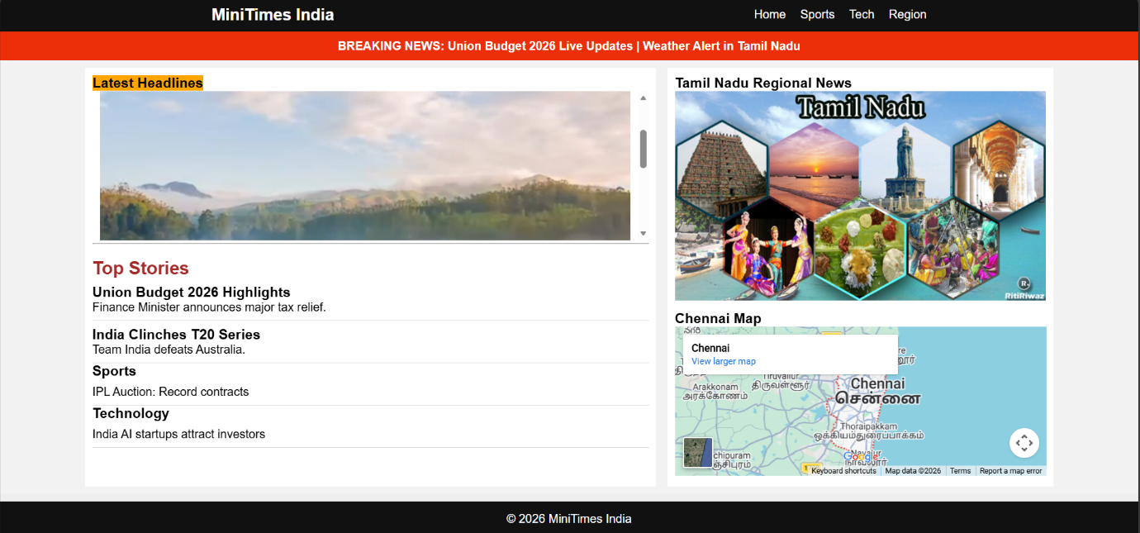

Result:
Html Page is created with embedded Bangalore map along with hot spot, frames ,map & Links.

